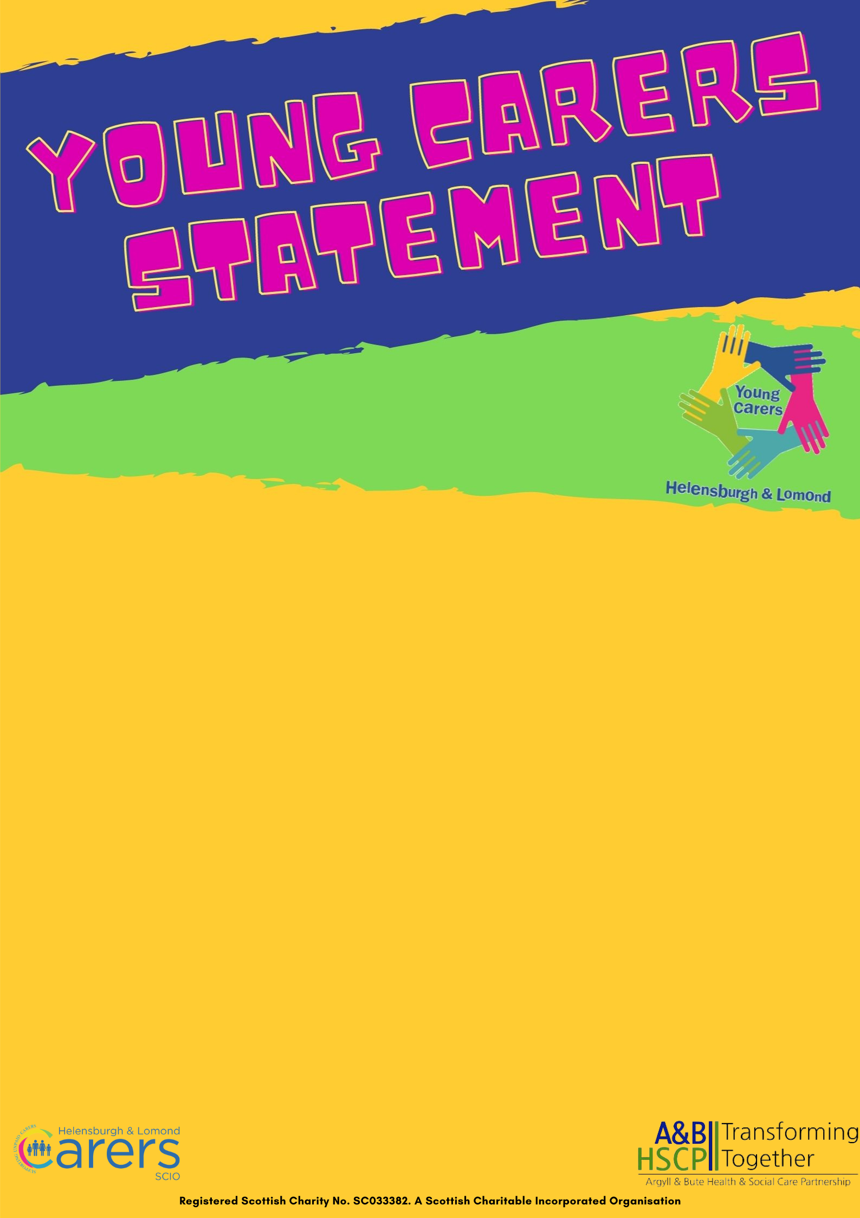

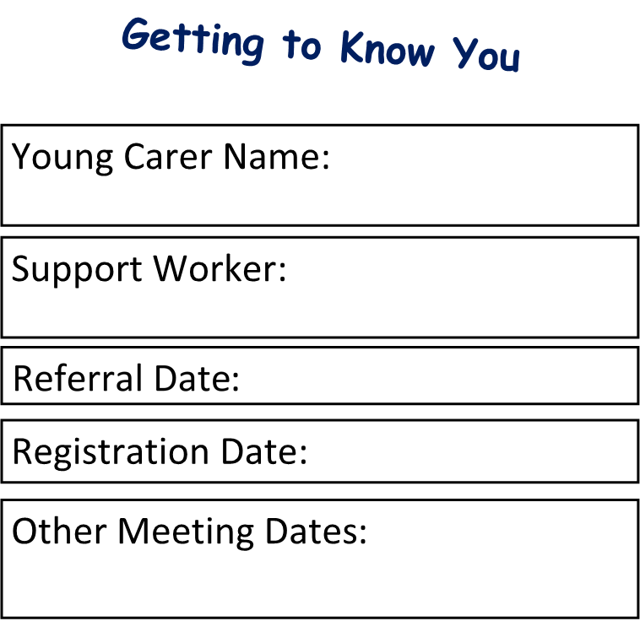

Contents Page and Date Completion Tracker
Introduction- What is a Young Carer and a Young Carers Statement | Page 2
More About You | Page 3
School and Education | Page 4
Wellbeing | Page 5
Wellbeing web | Page 6
My Caring Role | Page 7
What My Week Looks Like | Pages 8
What I Do and How I Feel | Page 9-10
Action Plan | Page 12-13
Agreement and Consent | Page 14

Who is a Young Carer and why are we meeting?
Many young people and their families do not realise that they are a young carer. A young carer is someone who provides unpaid care to a family member or other person who has an illness, disability, mental ill health or who experiences problems related to substance misuse. You might not think that you are a young carer, but maybe someone who knows you thinks you are, and has asked us to support you.
- no matter how little caring you do, you can still be a young carer
- if you are aged 5 – 15 years you are a young carer
- if you are 16+ you are a young adult carer
- if you are 18+ you will begin the transition to the adult carers services
- all young carers, by law, have the right to a Young Carers Statement (YCS)
- your YCS sets out what you need, your goals, and how you might achieve them with help if needed
Helensburgh and Lomond Young Carers Team are here to help you complete your statement.
- to do this we will first receive a referral to tell us you might be a young carer
- then we will contact you/your parent to explain the service we can offer
- after this, we will send to you the link to register with us
- when you are ready, we make our way through the Young Carers Statement
- this is done in your own time
- we are here to support you
What is a Young Carers Statement (YCS) and Action Plan?
Young Carers Statement: We will book 1:2:1s with your Support Worker and go over the Young Carers Statement, which you complete in your own time or with your Support Worker. You will answer some questions about yourself, and from the information you share, your Support Worker will help you decide some goals - These are things you would like to achieve or change (you can choose if you would like to share these with anyone, for example - school).
What happens next? After completing your YCS we record your goals in your Action Plan, along with a list of things we will do to help you achieve them. The support that is offered may be from Helensburgh & Lomond Carers Centre (HLCC) young carers or other organisations. These will help you reach the goals that you have set and will show what support you need to achieve them.
Action Plan: Your action plan will support you in achieving your goals. It will help us review how you are doing, and if there is anything we can do to break down barriers that may be stopping you achieving your goals. If you meet your goals, we look at the successes, how you reached them and help we set more goals. If you have not managed to reach your goals, we will have a chat about what you think we need to change to help you reach them, or you may want to change your goals.

More About You:
Conversation starters/questions:
- What kind of things do you like to do at school?

- What are your favourite activities/hobbies out of school?

- Who lives in your house? (relationship and age)

- Who do you help look after?

- Why do they need you to help them?

- Are you able to leave the person you care for on their own?

School and Education

School and Education
What school do you go to and what year/class are you in?

Who is your guidance teacher/class teacher?

What do you enjoy most about school?

What do you not like so much about school?

Are you ever late to school? If so, is this ever because of your caring role? If not, then why?

Do you manage to get your homework done or have help if you’re stuck?

Do you ever worry about the person you care for when you’re at school? And if so, what is it you are thinking or worrying about?

Have you ever had to miss school because of your caring role?

Do teachers at school know about your caring role and would you like them to know?

Is there someone at school you can talk to about your caring role, or when you get worried about it?

Wellbeing–Mental, Physical, Emotional and Social Health
Do you have any health conditions or need support from others?

Does your caring role have an impact on your physical health? Like sleep, tiredness, aches and pains?

Does your caring role affect how you feel and cope with things? Like your mood, concentration, homework, feeling stressed or worried and how you react to things?

Does your caring role ever prevent you from doing things you enjoy?
Who are some of your friends?

Do you spend time with friends outside of school?

Do your friends know you care for someone? Would you like to tell them if they don’t?

Do you ever get teased or bullied?
What could help you cope better with your caring role?

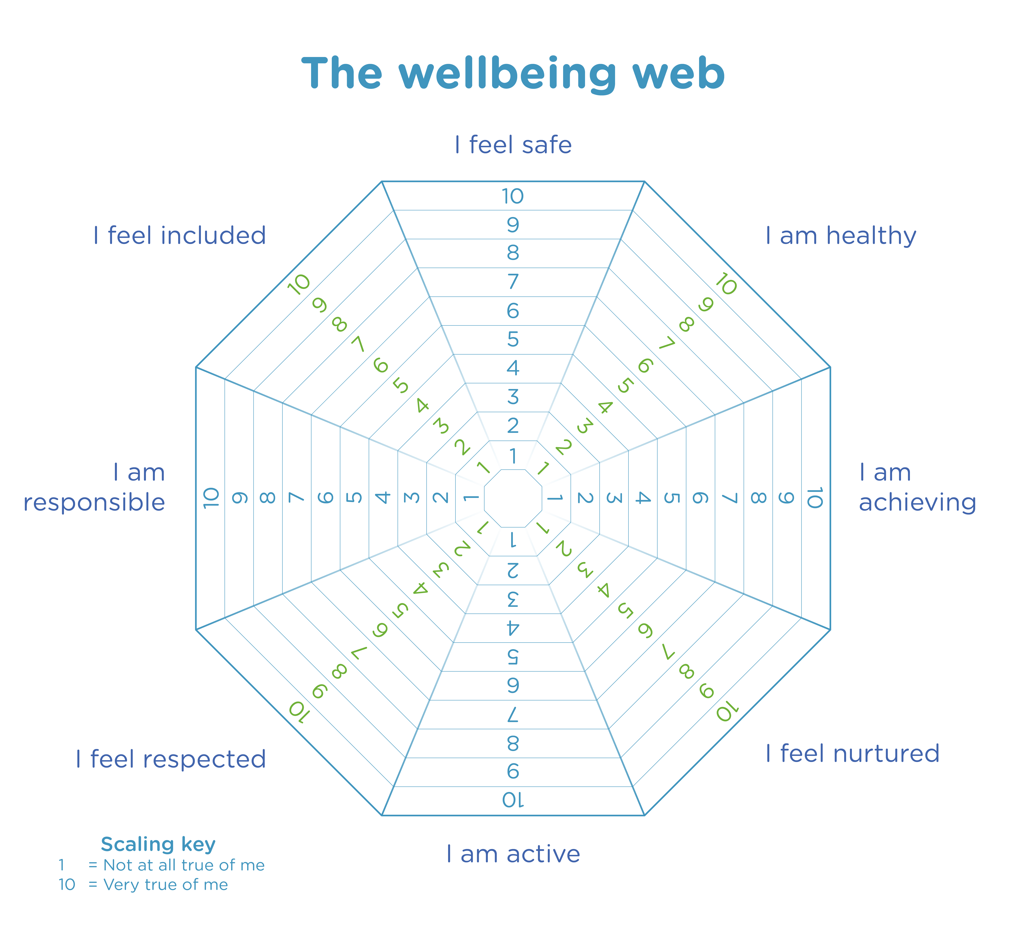
Notes/Comments
My Caring Role
What does your caring role look like in a typical week? (You can use page 8 to tell us more)

Do you do more in your caring role at weekends and during school holidays?
What jobs do you do during the day? Would you still do these if you didn’t have a caring role? i.e., Chores

What jobs do you like doing and why?

What jobs do you not doing like and why?

Are there things about caring that make you feel good?

Are there things about caring that upset you?

Is there someone who helps support the person you care for? Home help, other family. (Details)

Who would you go to if you needed help with your caring role, or just wanted to talk about it?

Do you feel like you get enough ‘me’ time? If not, what do you think would help with that?

Is there anything you feel you need help with?

Are you able to carry out your caring role? If not, what support do you think you need with this?

Are you willing to carry out your caring role? If not, what support do you think you need with this?

Do you feel included and listened to…in conversations/decisions about your cared for person?
What My Week Looks Like
What are the things you do...
Monday
Tuesday
Wednesday
Thursday
Friday
Saturday
Sunday
What I Do and How I Feel?
 | Never (0) | Sometimes (1) | A lot of the time (2)
Clean your own bedroom
Clean other rooms (living room, bathroom, kitchen etc)
Wash up dishes or load dishwasher
Do food shopping
Help with lifting or carrying heavy things
Help financially (dealing with bills, banking, benefits, work to bring in money)
Interpret/sign or use another communication system for the person you care for
Help the person you care for get dressed/undressed
Help the person you care for wash/bath/shower or any other personal care
Are you responsible for administering medication or personal medical care
Keep the person you care for company or look after them and make sure they are ok
Responsible for taking the person you care for out
Responsible for taking siblings to school
If your sibling is not who you mainly care for do you still help them get washed, dressed, change nappies etc
Do you look after siblings with another adult near by
Do you look after siblings on your own
Do you help look after any family pets

Notes/Comments:
Is there anything else you help with i.e. – Take bins out, do the gardening, DIY/Fix things around the house, phone doctors, pick up prescription? etc
Because of Caring… | Never (0) | Sometimes (1) | A lot of the time (2)
I feel I am doing something good
I feel that I am helping
I feel closer to my family
I feel good about myself
I feel that I am learning useful things
My family are proud of the kind of person I am
I like who I am
I feel good about helping
I feel better able to cope with problems
I feel I am useful
I feel stressed
I feel like running away
I have trouble staying awake or going to sleep
I must do things that make me upset
I feel very lonely
I feel like I can’t cope
I can’t stop thinking about what I must do
I feel sad and I can hardly stand it
I don’t think I matter
Life doesn’t seem worth Living

Action Plan
 | Outcomes and goal setting | Support required to achieve | Timeline | Progress, achievements, changes, and dates
Caring Role
Thoughts and feelings
Wellbeing
Me time
Hobbies and interests
School
Anything else important
Areas for action

Agreement and Consent
Sometimes we might have to share information with other people/services. Because this is your information, we feel it is important that you agree and consent to this before we do so. Your Young Carers Statement and Action plan will help others understand your role and how best to support you to achieve your goals, but this is only shared if necessary and we will always double check with you first.
We wish to build a trusting relationship hoping you will feel comfortable talking to us allowing you to share information as freely as you like without being judged. We also want you to know that confidentiality is very important to us. This means we will not share anything you tell us unless you or someone else is in danger or harm’s way. This might sound scary, but our priority is young people’s safety and that’s why we want you to know this. If you share something with us that we feel we will need to discuss with another staff member or partners we will tell you first, explain why, what, and how. You will always be kept in the loop!
When attending group, activities or engaging in 1:2:1s we will treat you and your families with respect, and we ask the same in return. As mentioned, everyone’s safety is our priority and this means, listening to staff and following group rules agreed set at a group or activity.
If you have any questions about the above, please ask and we will clarify before signing. If you feel you understand then please sign below.
Young Carers Signature
Date signed
Support Workers Signature
Date Received

