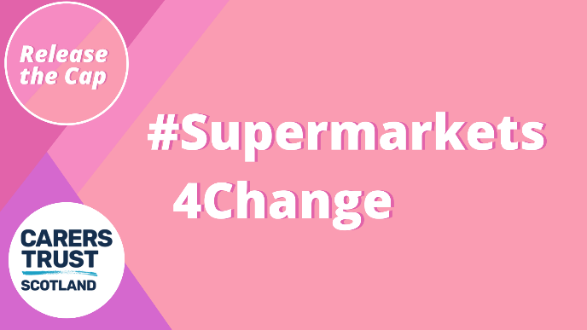
MANAGER NAME
STORE NAME
STORE ADDRESS
CITY
POSTCODE
DATE

Supporting our Young Carers during COVID-19

Hello,
I hope you are safe and well during this time.
My name is NAME, I am AGE years old and live in LOCAL AREA.
I am writing to you today to raise awareness of young and young adult carers in the local area. I want to start by recognising and thanking you for your support to NHS and front-line workers during this time. I really value the changes that have been brought in and hope we can work together to extend the support to unpaid carers.
A young carer (under 18) and a young adult carer (aged 16 – 25) are young people who help look after someone else in their family, or a friend, who is ill, disabled or misuses drugs or alcohol. Young carers are unpaid and during this lockdown, are facing many challenges to their caring role.

(Optional) Example from your local community: In your store, some young/ young adult carers have raised the issue that ______________________________________________________________________________________________________________________________________

Please understand that it is not always possible for a young carer to go to the shop alone or at a specific time when they have such a large caring role.
The aim of this letter is to raise awareness of young carers in LOCAL AREA. Please can you consider including unpaid carers in the dedicated shopping time for key workers and vulnerable people?
I understand that this is a challenging time for businesses, but we must recognise the role that young and young adult carers play in our society. I would be happy to discuss this further with you and hope that we can work together in the future to further support young carers in the local community.

Thank you,
NAME

