STEP 3
08
Fal
Tool 2:
Exemplar introductory letter to governors about young carers
08
Fal

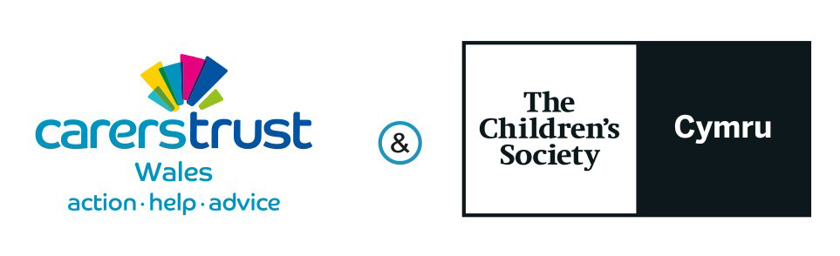

Purpose

This exemplar letter aims to support the school’s staff to raise the governing body’s awareness of young carers, and their role and responsibilities in ensuring effective identification and support for young carers.

Guidance

If your school is part of a federated governing body, we recommend that you send the letter to the federated governing body. Doing so will enable them to decide whether to delegate responsibility for young carers to any local committees/governing bodies.

Governors will find the following tools from the Step-by-step Guide particularly useful and you may wish to include a copy of these resources with the letter:

• Step 4: Gaining an understanding of young carers.

• Step 3 Tool 3: Role and responsibilities of a governing body: ensuring effective provision for young carers and their families.

• Step 3 Tool 4: Checklist to support governing bodies evaluate the effectiveness of their school’s provision for young carers and their families.

• Step 3 Tool 5: Targeting pupil deprivation support to young carers: Good practice examples.

Dear governors

Meeting the needs of young carers at [INSERT NAME OF SCHOOL]: Information for governors

At [name of school] we are aware that some of our pupils are young carers – children under 18 who are caring unpaid for a family member or friend who is ill, frail, disabled or has mental health or addiction problems. Young carers are a vulnerable and disadvantaged group who frequently experience difficulties in their education as a result of their caring role. They are specifically mentioned in Estyn’s evaluation inspection guidance and are often eligible for free school meals and Pupil Development Grants.

Identifying and supporting pupils with caring responsibilities is a low cost and effective way of improving the attainment of this often low achieving pupil group. We are therefore keen to ensure that our governors have the information and resources they need to consider the needs of young carers as part of their evaluation of the school’s provision, and how well it meets the needs of our pupils.

As part of the Young Carers in Schools programme, a national initiative to equip schools for effective practice, Carers Trust Wales and The Children’s Society Young Carers in Focus partners have produced specific resources for governors. Relevant resources are enclosed and include:

• Key information about young carers and the potential impact a caring role can have on a pupil’s academic achievement, attendance and wellbeing.
• The roles and responsibilities of the governing body in ensuring effective provision for young carers.
• Frequently asked questions for school governors and senior leadership teams.
• A checklist to support governing bodies in evaluating the effectiveness of their school’s provision.
• Further information about the Young Carers in Schools programme.

We recommend that governors schedule an agenda item to discuss their school’s support for young carers. We encourage the governing body to consider appointing a lead governor with this remit and to agree how the governing body will carry out its responsibilities in relation to young carers.

The school has/intends to appoint a Young Carers School Strategic Lead who will carry out a baseline review of the school’s current provision for young carers and their families. We will provide a summary of this review and relevant recommendations prior to your discussion.

Yours faithfully

Carers Trust is a registered charity in England and Wales (1145181) and in Scotland (SC042870). Registered as a company limited by guarantee in England and Wales No. 7697170. Registered office: 32–36 Loman Street, London SE1 0EH.

The Children’s Society is a registered charity number 221124. Registered Office: Edward Rudolf House, Margery Street, London, WC1X 0J

© Carers Trust 2017

