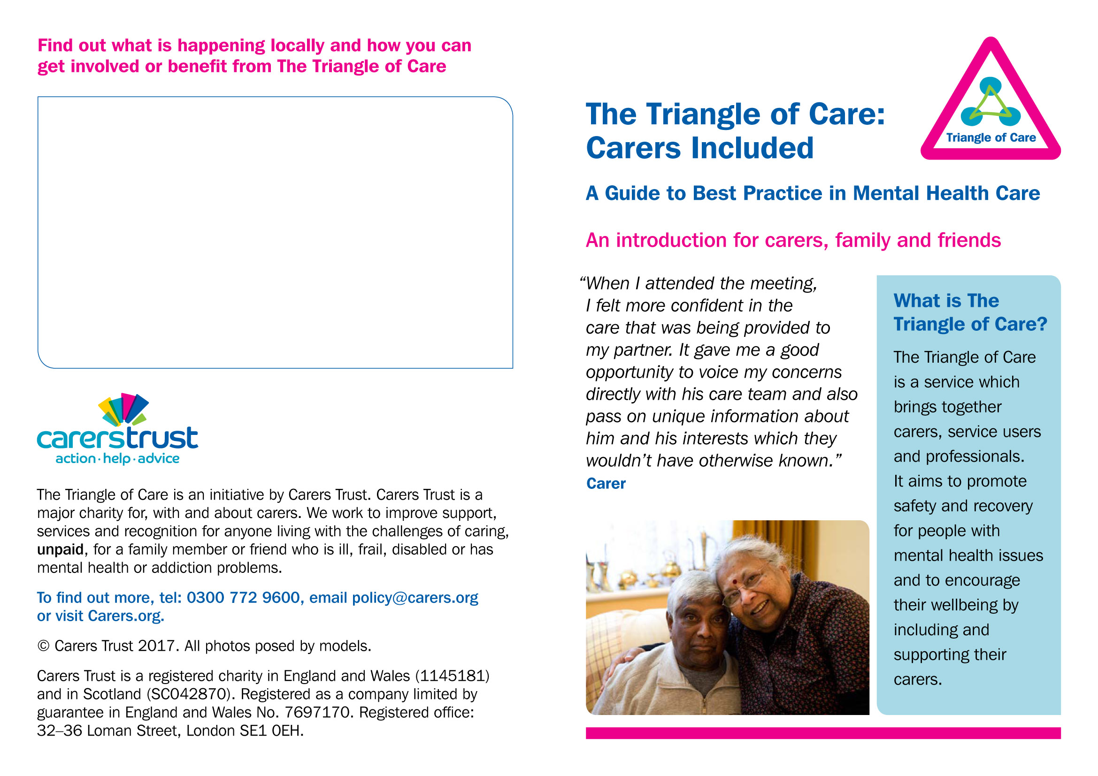

Please delete the text in this box, and replace it with any information you would like to add about your own organisation, including your contact details.

You can also add your own logo.

